S1000D & Integrated Product Support (IPS) User Forum
Call for Abstracts is Currently Open
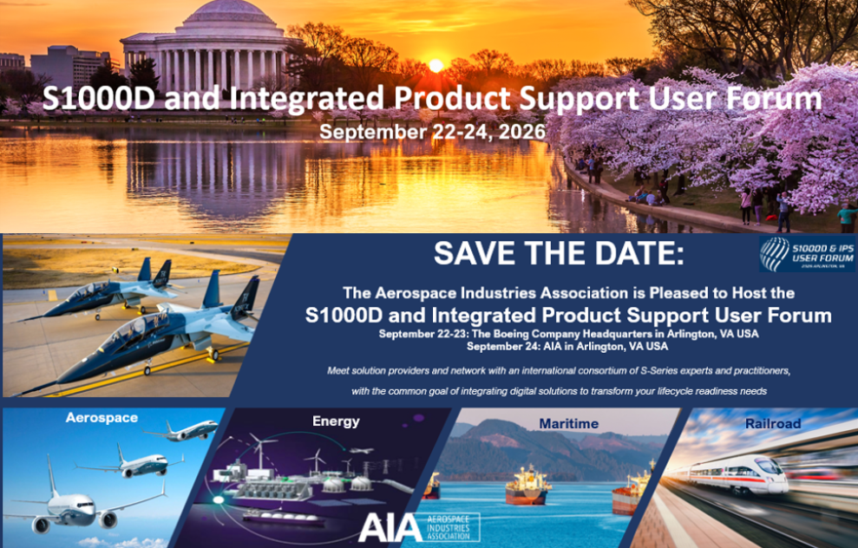
Please Submit your abstract By May 29, 2026
Dear Sir or Madam,
The Aerospace Industries Association is pleased to host the 2026 S1000D and Integrated Product Support (IPS) Specification User Forum in Arlington, VA (Washington, DC) on 22 - 24 September 2026. You are invited to submit an abstract addressing topics related to the S-Series Specifications. The form for submitting an abstract is attached here:
Information related to the event will be released in April 2026. Should you have any questions related to abstracts, please forward them to Dawn Meyer, AIA Manager - S-Series, at dawn.meyer@aia-aerospace.org .

Regards,
Dawn Meyer | Manager – S-Series Specifications
AIA | 1000 Wilson Boulevard, Suite 1700, Arlington, VA 22209
T: 314-705-1064 | dawn.meyer@aia-aerospace.org
aia-aerospace.org

2026 S1000D & IPS User Forum
Call-For-Abstracts Submission Form

Abstract Requirements
- Abstracts must be provided on this Form (English only).
- Abstracts are to be submitted March 30 through May 29, 2026.
- Abstracts and presentations must be non-proprietary and releasable to the public.
- Abstracts must pertain to S1000D or S-Series IPS specifications.
- Individual speaking sessions are offered 30 minutes in length.
- Panel sessions are limited to 90 minutes, including time for questions and answers. Requests for additional time will be considered.
- Presentations are to be non-attributional.
- No product marketing presentations will be accepted.
- Not all proposals will be accepted.
- Please email abstracts to: dawn.meyer@aia-aerospace.org

Presentation
Presentation Title | Click here to enter text.
Choose topic (pick one) | ☐ S1000D  ☐ S-Series IPS Specifications
Applicable Standards | Click here to enter text.
Choose topic (pick one) | ☐ Technical  ☐ Management  ☐ Use Case Scenarios  ☐ The Common Data Model  ☐ Contracting  ☐ Data Conversion  ☐ Data Exchange between product lifecycle disciplines for a project  ☐ How the S-Series compare with their companion Mil-Spec  ☐ How do I?  ☐ Product Demonstration
Subject / Topic(s)
Permission to publish online | ☐ By checking this box, I agree that if my proposal is selected, I authorize the event organizers to post a PDF version of the presentation to the S1000D and S-Series web sites for public viewing.
Presenter
Name | Click here to enter text.
Job Title | Click here to enter text.
Company | Click here to enter text.
Address | Click here to enter text.
Email Address | Click here to enter text.
Phone Number | Click here to enter text.
Proposal submitter (if different than the Presenter)
Name | Click here to enter text.
Email Address | Click here to enter text.
Permission to publish Bio on event APP | ☐ By checking this box, I agree that speaker(s) will submit their professional Bio(s), with high resolution headshot(s) within 14 business days of abstract being accepted. If the abstract if selected, I authorize the event organizers to post a PDF version of the bio and headshot to the S1000D and S-S-series web sites for public viewing.  Please submit Bio and headshot to:  dawn.meyer@aia-aerospace.org

Brief abstract of the presentation (maximum 500 words), containing:
- An introductory paragraph that summarizes the subject matter and scope of the presentation.
- Brief description of the key points/issues that will be discussed.
- The sequence in which the information will be provided.
Click here to enter text.

